Naval Operations and Integrated Logistics Simulator (N-OILS) v3.16

CODE AND RUN FILES: Version 3_16
YAML Libraries: These are all dynamic. This means that if you load a new .yaml, you will get different run properties based on the content in the .yaml.
alternative_fuel.yaml: This .yaml sets the fuel properties that the model uses (density, volumetric energy density, and cost).
baseline_ships.yaml: This .yaml sets ship baseline energy burn to speed relationships. It also sets the speed limit for the ship and the volumetric fuel capacity.
movement_profiles.yaml: This .yaml sets the speed profiles used by the Dragon Taming #1 scenario (operational speed, refuel speed, and surge to theater speed). Changes to these values will dynamically change the model behavior.
refueling.yaml: This .yaml sets the locations where ships may receive refueling. This is required to be at least one location, and the location(s) do not have to be the point(s) of origin. Changes to these values will dynamically change the model behavior.
# sea_state.yaml: This .yaml sets the likelihood of ships being in the listed sea states and the energy penalties for each sea state. Changes to these values will dynamically change the model behavior.
N-OILS_Main_Code_v3_16.txt: This is the core code (the actual model).
N-OILS_Self-Test_v3_16.txt: This is the self-check code (which helps check and see if the model broke with an update or not).

COLAB LINK
https://colab.research.google.com/drive/1ktszdgkvNF4pJeA0Lfw79Js2NBPqJK6I?usp=sharing

LOGOS
The following are some potential logo concepts for N-OILS. Please review and identify preferences or requests for further iterations.
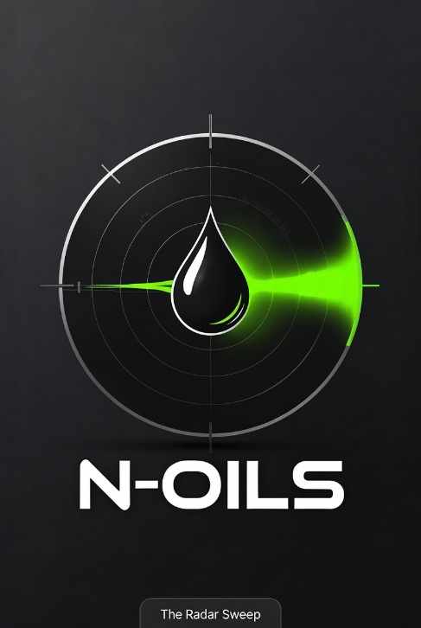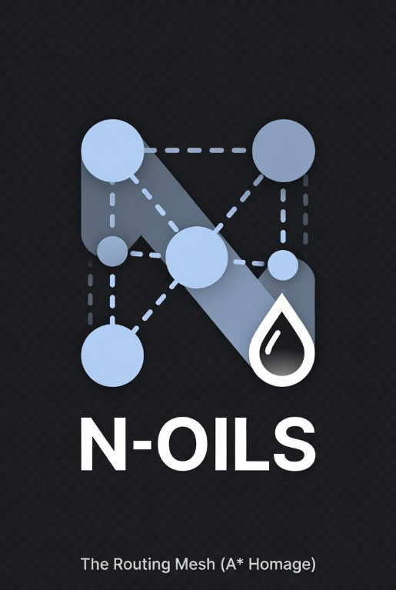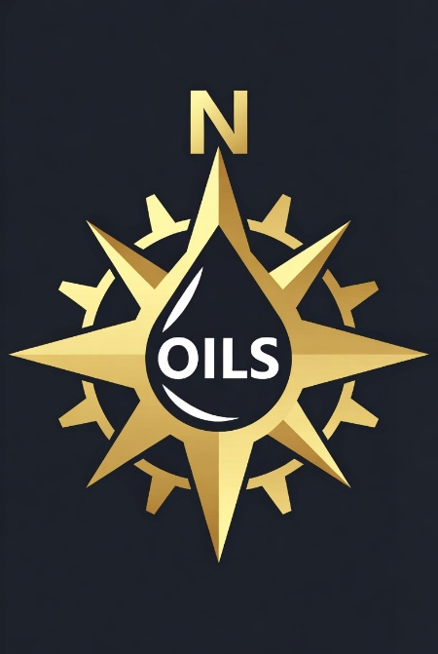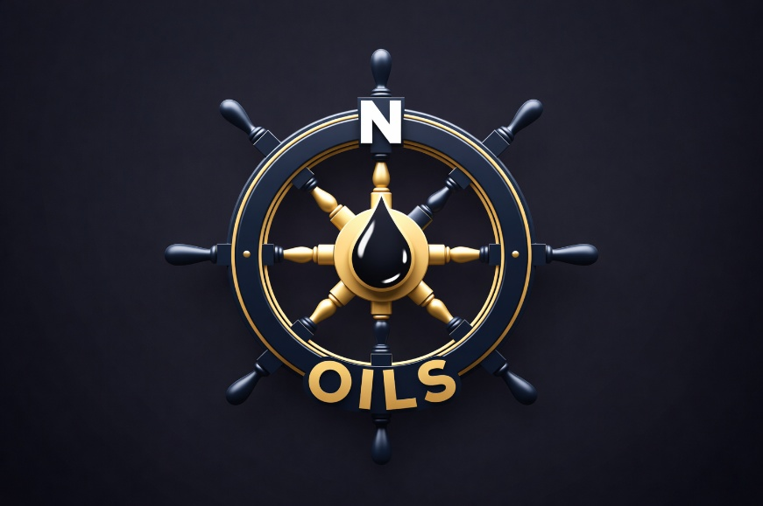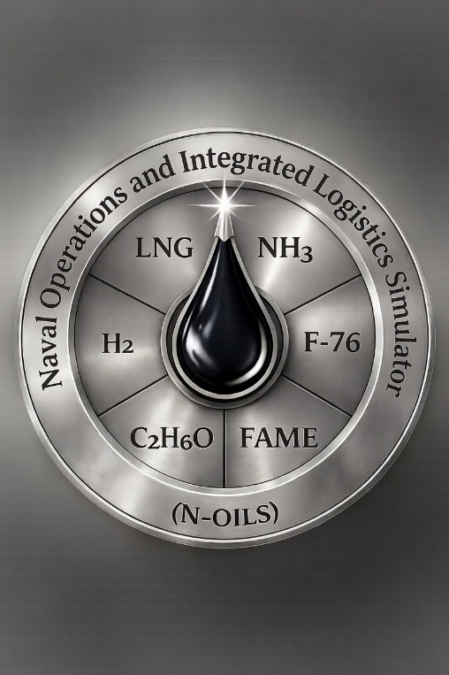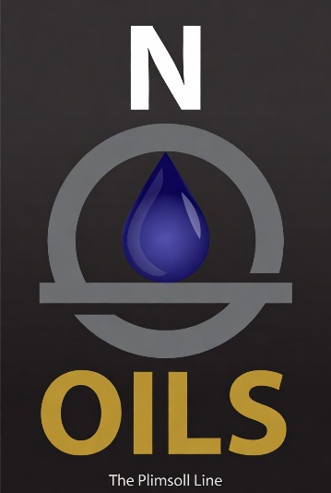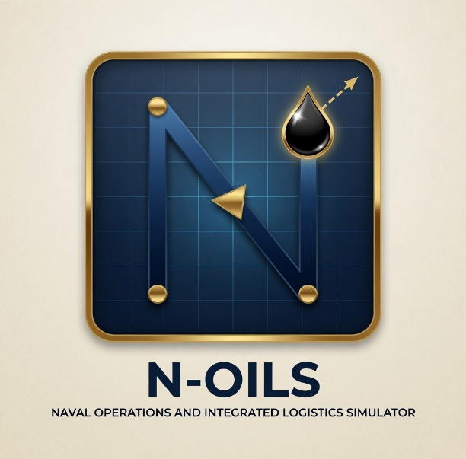

TASKS
- All: Review all files and verify that you can run the model on your own.

- All: Perform verification and validation testing: This link goes to a spreadsheet with a designed test series. There is one run already assigned to all members of the team. Please select at least three others to run.

When you run the already assigned and highlighted run, please pass your data (excel files) to Jakob. Jakob will use those files to help test the Monte-Carlo run that is assigned to him (also highlighted).

It is better to do less runs and scrutinize the values for conformance to the dictated model behavior than to do more runs. If you only get one quality test done, that is better than getting five low quality tests.

Record any notes or observations, things that need to be fixed in the notes section of the spreadsheet. If you need additional space, please create a file that you link to in the notes.

- Jakob: Take the MASC data and regress it. Update the baseline_ships.yaml in a folder for Version 4 (the version of N-OILS that we will use for the thesis analysis).

- Jakob: Take the fuel cost data (high and low) and create a high an low alternative_fuel.yaml in a folder for Version 4 (the version of N-OILS that we will use for the thesis analysis).

- Garry: Provide the recommended refueling locations to Jakob.

- Jakob: Take the recommended refueling locations and update the refueling.yaml a folder for Version 4 (the version of N-OILS that we will use for the thesis analysis).

- All: Review logo designs and provide votes or inputs for alternative selections.

- Jakob: Work on updating all relevant thesis sections with detailed model behavior notes – matching the current codebase.

- Somebody? Work to put all code and files into the git repository for better long-term sharing and use. Work up a help guide on how to run the code in the repository from google colab. Or suggest something else that is better.

